Feb 2. 2018

1. **Are the places with the most # larval mosquitoes consistent across years?**

**Maybe. But 2012 lower abundance in all cases.**

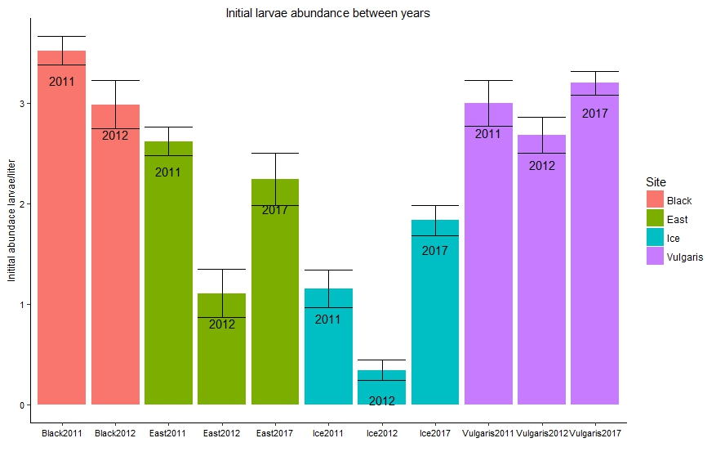

1. **Are the places with the most # beetles consistent across years?**
2. **Are the places with the most # of emerging mosquitoes consistent across years?**

**No. But limited data to answer this question.**

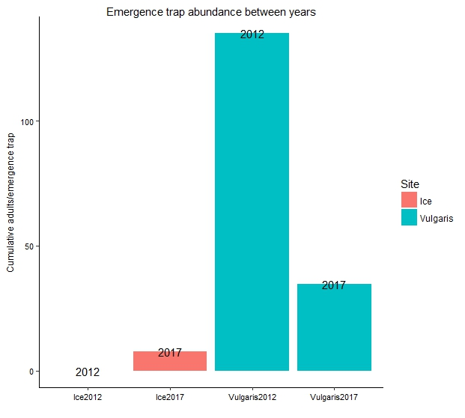

1. **Do ponds with more early instar mosquitoes have more emerging mosquitoes?**

**Maybe. Either no relationship, or positive**

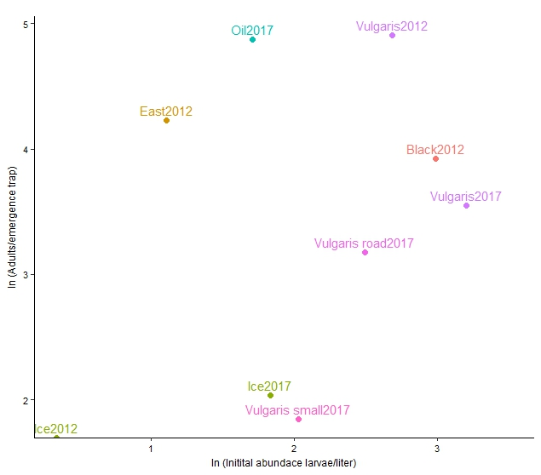

1. **Are the places with the largest mosquitoes consistent across years?**

**Plot when I have more data.**

1. **Do ponds with more emerging mosquitoes have smaller emerging mosquitoes?**

**No obvious relationship, but not a lot of data**

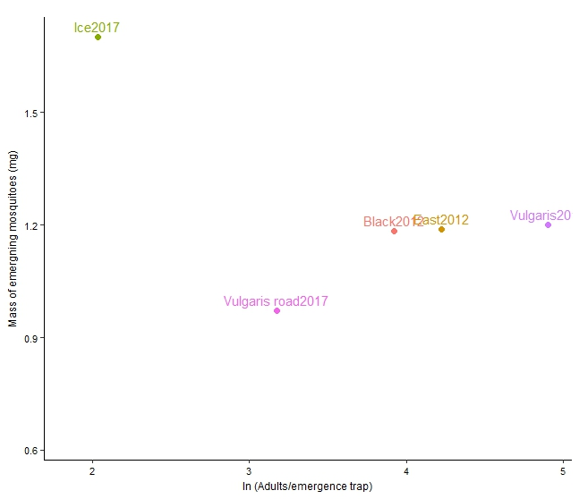

1. **Do ponds with greater densities over early instars have smaller emerging mosquitoes?**

**No it’s the opposite…when there’s more larval mosquitoes they are bigger**

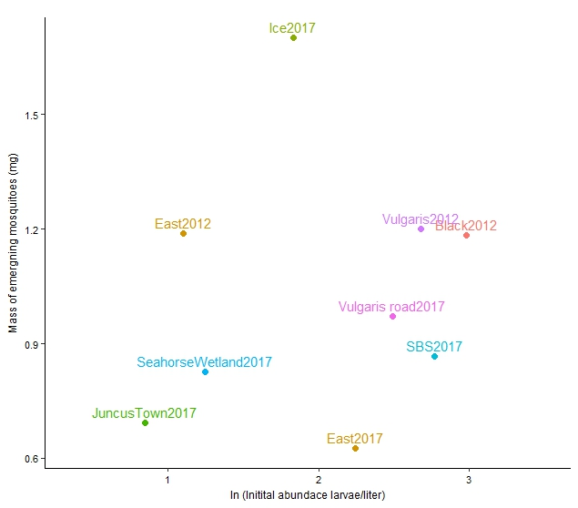

1. **What is the relationship between mass and wing length?**

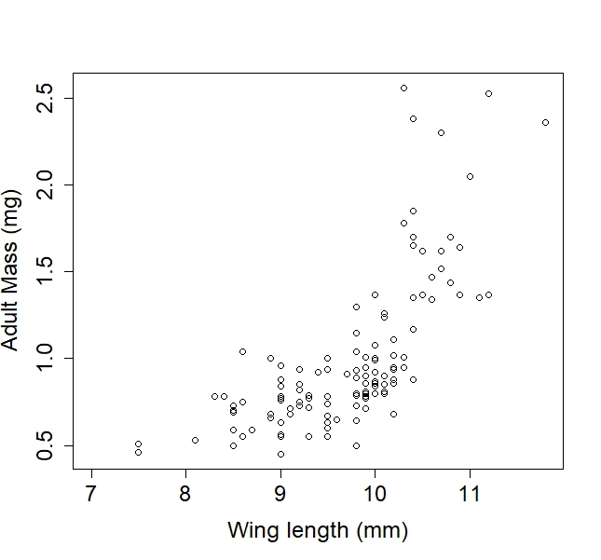

1. **Does mass differ between male and female adults?**
2. **Do sex ratios vary between ponds?**
3. Are there more larval mosquitoes in places that are wet every year or places where it is only wet every couple of years (egg bank?)

Predators

1. **Do ponds with a lot of mosquitoes have a lot of predators?**
2. **Do beetles appear earlier in warmer ponds?**
3. Do ponds with more predators have higher rates of per-capita mortality? (but look AFTER beetles are there)
4. Is there a difference per-capita mortality before and after predators appear?

Densities

1. **Do ponds with higher densities of larvae have higher per-capita mortality?**
2. **Do ponds with more larval mosquitoes have smaller emerging mosquitoes?**
3. **Do ponds with higher per-capita mortality rates have smaller emerging mosquitoes?**
4. **Do ponds with higher per-capita mortality rates have fewer emerging mosquitoes?**
5. **Do ponds with a higher average mass of emerging mosquitoes have a greater variance in size distribution?**

Temperature/Timing

1. **Do more mosquitoes emerge from warmer ponds?**
2. **Do mosquitoes emerge earlier in warmer ponds? (yes, duh)**
3. Do colder ponds have more days where mosquitoes and beetles overlap?
4. **Are mosquitoes that emerged earlier bigger?**

DOC (…ideally do this with better food data)

1. **Do ponds with more DOC have more emerging mosquitoes?**
2. **Do ponds with more DOC have larger emerging mosquitoes?**
3. **Assuming constant DOC over the larval period, is there a relationship between per-capita mortality and DOC/density?**

Relative growth rate data

1. How does size distribution change as density decreases?
2. Do mosquitoes grow more slowly in colder ponds?
3. Do mosquitoes grow more slowly when there are more of them (food limited)?
4. Do mosquitoes grow faster in places with higher DOC? (or food…)
5. Do mosquitoes grow faster in places with higher DOC/density ratio?

C02 trap data

1. Is adult mosquito abundance aggregated on the landscape?
2. Is mosquito abundance aggregated in the beginning (according to where they emerge) and then become more random/uniform over time?
3. Are there more mosquitoes in places where the probability of getting a blood meal is higher later in the season?
4. Will mosquitoes seek a blood meal on windy days?
5. Will mosquitoes seek a blood meal on cold days?
6. Will mosquitoes seek a blood meal on dry days?

Egg/sweep net data

1. Is the probability of getting a blood meal uniform across the landscape?
2. Are there more mosquitoes in places where the probability of getting a blood meal is higher?
3. Do bigger mosquitoes have more eggs?
4. What percentage of the population could be reproducing without a blood meal (autogeny)?
5. Where are the majority of blood meals coming from?

Stuff I don’t really have data on yet…

1. What makes a good mosquito pond?
   * In terms of # initial densities
   * # of emerging mosquitoes
   * AND size of emerging mosquitoes
2. What other aquatic inverts are eating the same food as mosquitoes?
3. Are there other organisms better at eating food than the mosquitoes (lower R*) and if so, why are they not in the mosquito ponds? (Are they dispersal limited?)